**Table of Contents**

**Introduction** **3**

Purpose of the document 3

**System design** **3**

Table of Use cases 3

Use cases diagram 3

Component model 3

Sequence diagram 4

**System development** **5**

Programming language 5

Used technologies 5

Used IDEs and tools 5

**Revision History**

|  |  |  |  |
| --- | --- | --- | --- |
| **Name** | **Date** | **Reason For Changes** | **Version** |
| Paul Komarnytskyy | 04/18/18 | Initial Draft: added use case table, use case diagram, sequence diagrams, used technologies and languages, used IDEs, component model | 1.00 |
|  |  |  |  |

# **Introduction**

## **Purpose of the document**

This document provides a comprehensive architectural overview of the system, using a number of different architectural views to depict different aspects of the system. It is intended to capture and convey the significant architectural decisions which have been made on the system.

# **System design**

## **Table of Use cases**

For table of use cases, see [Vision And Scope](https://docs.google.com/document/d/180YUTqV-xdK6-1jgmSpF_Tz5fHCuuUaa040zJ5nMOSs/#heading=h.t565dgqkvmgo) document.

## **Use cases diagram**

For use case diagram, use [Vision And Scope](https://docs.google.com/document/d/180YUTqV-xdK6-1jgmSpF_Tz5fHCuuUaa040zJ5nMOSs/#heading=h.e6pbug25bxjq) document.

## **Component model**

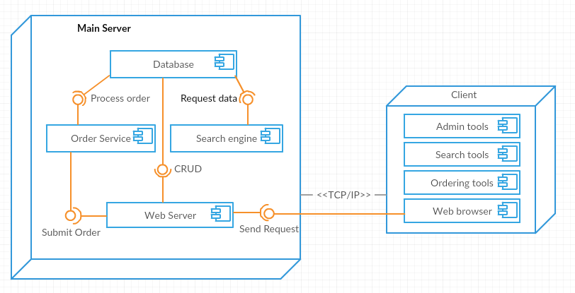

## **Sequence diagram**

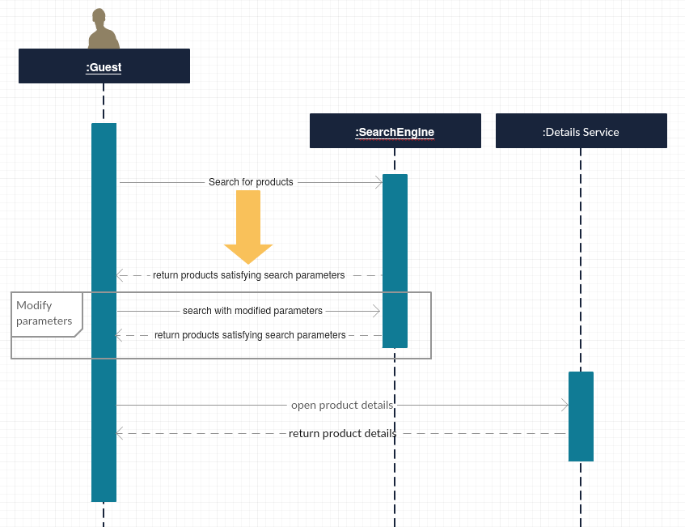

Search for products sequence diagram

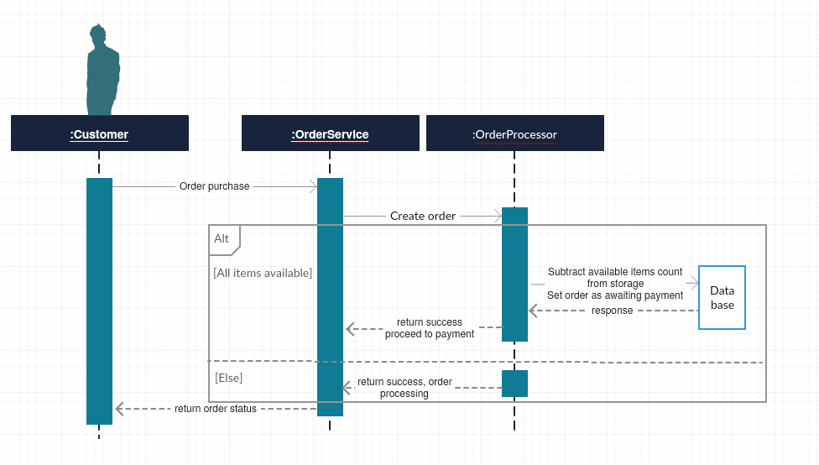

Ordering sequence diagram

# **System development**

## **Programming language**

Server side of the project is to be written in C#.

Core project with all of the business logic is to be written also in C#.

Client side of the project (website) is to be written with the usage of C#, JavaScript, SCSS, TypeScript and HTML.

## **Used technologies**

The server uses ASP.NET Web API 2 for handling web requests, OWIN for authentication and Entity Framework for database connection.

Core project uses only Entity Framework apart from basic C#.

The website uses Angular 5 for achieving SPA, ASP.NET MVC 5 for base navigation, routing and website setup and WebGrease for web optimisation. Gulp can be used for typescript compilation

## **Used IDEs and tools**

For development following IDEs/tools are to be used:

* Microsoft Visual Studio 2017 Community
* Sql Server Management Studio 2017
* IIS
* Node package manager
* Google Postman